RegInald True

Professor Lles

CS 360

29 March 2025

Xbox App Redesign

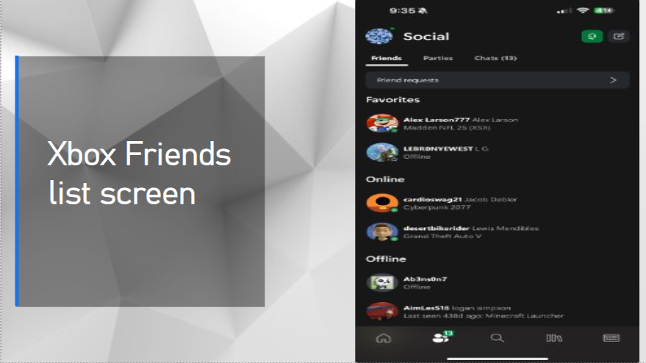

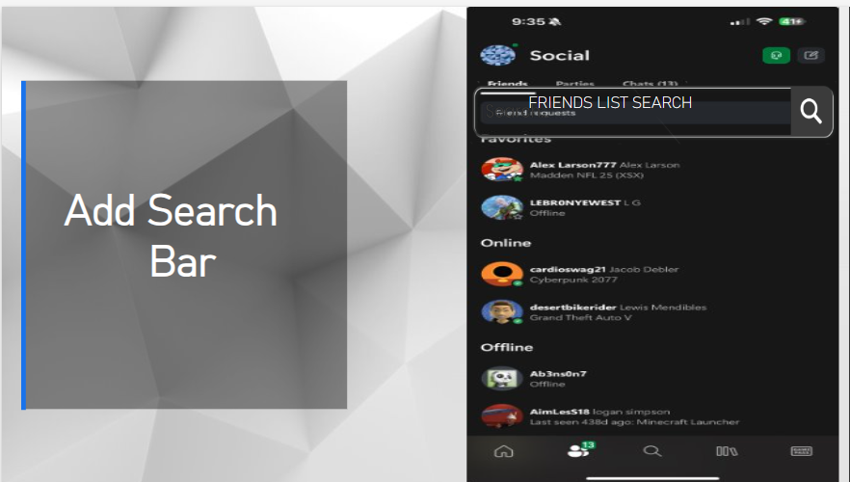

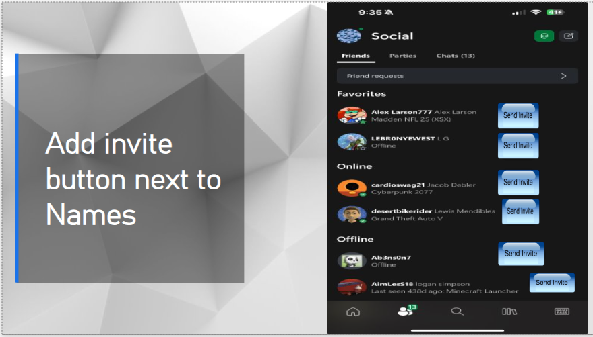

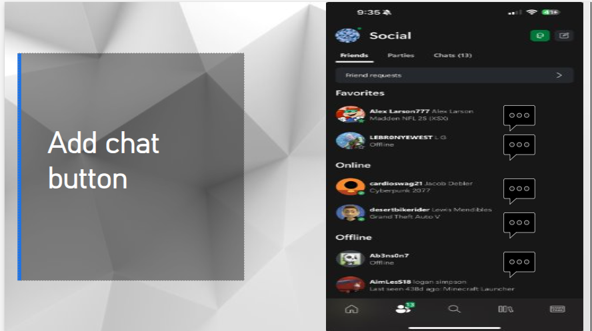

* **Profile Pictures and Names** – Each friend has a small picture and their name next to it.
* **Status Dot** – A green dot shows if a friend is online, and a gray dot means they’re offline.
* **Chat Button** – Next to each name is a small message icon. You can tap it to start chatting.
* **Invite Button** – There's a game controller icon you can tap to invite them to a game.
* **Search Bar** – At the top, users can search for friends by typing their name.
* **Navigation Bar** – At the bottom, I added a bar with buttons for Home, Games, Friends, and Settings
* **New Button: Add Friend** – I added a big Add Friend button so users can add new people more easily.

I made these changes to help users find and talk to their friends more quickly. In the old Xbox app, it was a little hard to invite friends to play games, and the buttons were small. In my new design, I made the buttons bigger and easier to tap. I also made the screen layout simpler so it's easier to understand.

I added a search bar at the top so users can quickly find a friend by typing their name. I also added a better navigation bar at the bottom, so people can switch to other parts of the app like "Home" or "Games" more easily. This helps users who have lots of friends or want to move around the app fast.

One hard part was fitting everything on the small phone screen. I fixed this by using clear spaces and simple icons, so it doesn’t feel messy or crowded. My new design still lets users see their friends, but it makes everything faster and easier to use. I used ideas from the Xbox app, good design rules, and my own creativity to make a screen that looks nice and works well.